TASK 3: REQUIREMENTS, ARCHITECTURE AND TECHNOLOGY SETUP
Containerized Event Sponsorship Tracker

1. SRS Summary
The System Requirements Specification (SRS) defines the minimum functional and non-functional requirements for the Event Sponsorship Tracker MVP. The system is a web-based application that centralizes event, sponsor and sponsorship information and provides search, dashboard, status drill-down and exception views.

1.1 Functional Requirements
ID | Requirement | Description
FR01 | Event Management | The system shall allow users to create and update event information.
FR02 | Sponsor Management | The system shall allow users to create and update sponsor information.
FR03 | Sponsorship Management | The system shall allow users to create sponsorship records connecting sponsors and events.
FR04 | Amount Management | The system shall record the sponsorship amount.
FR05 | Sponsorship Status | The system shall maintain the current sponsorship status.
FR06 | Payment Status | The system shall maintain payment status.
FR07 | Search | The system shall allow users to search events, sponsors and sponsorship records.
FR08 | Dashboard | The system shall display summary indicators.
FR09 | Status Drill-down | The system shall display detailed information for an individual sponsorship.
FR10 | Exception View | The system shall identify pending and overdue sponsorship records.
FR11 | Input Validation | The system shall validate mandatory fields and invalid input.
FR12 | Health Check | The system shall provide an application health/status endpoint.

1.2 Non-Functional Requirements
Requirement | Description
Performance | Normal dashboard and search operations should respond within a few seconds for the MVP dataset.
Maintainability | The application should use a layered structure with separated controller, service and repository responsibilities.
Portability | The application should run in the local development environment and inside a Docker container.
Reliability | Valid stored records should persist across application restarts.
Testability | Critical user journeys should be testable using Selenium.
Buildability | The application should build and package successfully using Maven.
Deployability | The application should be deployable behind Nginx and suitable for containerized deployment.
Automation | Build, test and deployment activities should be compatible with Jenkins automation.
Configuration | Server/application prerequisites should be manageable through Ansible in later tasks.

2. Use-Case Diagram
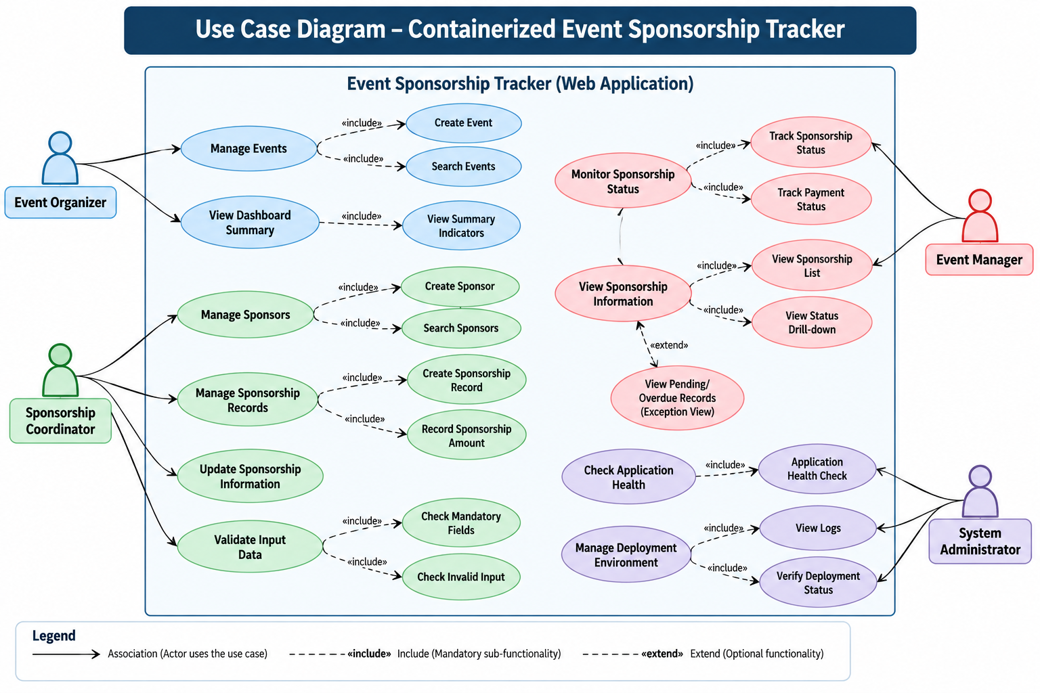
The MVP uses a general application User for event, sponsor, sponsorship, search, dashboard and exception operations. The Administrator performs the application health check.

3. Minimum Application Architecture

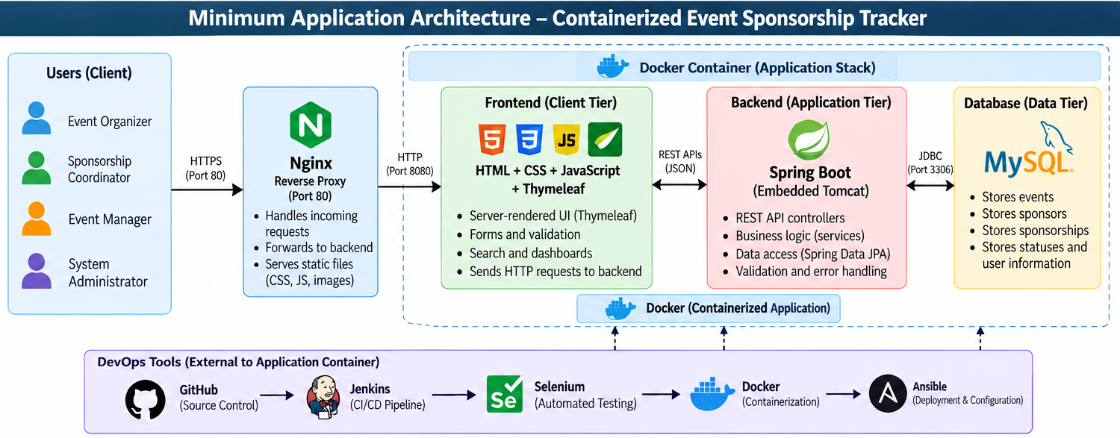
The proposed architecture uses a simple layered Spring Boot application. Nginx acts as the reverse proxy, while Spring Boot uses its embedded Tomcat server. MySQL provides persistent relational storage.

3.1 Architecture Components

Component | Purpose
Web Browser | User interface through which users access the tracker.
Nginx | Reverse proxy and entry point for the deployed application.
Spring Boot | Main backend application and request-processing layer.
Controller Layer | Receives HTTP requests and exposes application/API operations.
Service Layer | Contains application/business logic.
Repository Layer | Handles database access through Spring Data JPA.
MySQL | Stores events, sponsors and sponsorship records.
Docker | Packages and runs the application consistently in later DevOps stages.
Jenkins | Automates build, test and deployment pipeline in later tasks.
Selenium | Automates critical browser-based user journeys.
Ansible | Automates target environment configuration in later tasks.

4. Technology Stack
Component | Selected Technology | Purpose
Programming Language | Java 21 | Backend development
Framework | Spring Boot | Web application and REST/API layer
Frontend | HTML, CSS, JavaScript + Thymeleaf | Simple server-rendered user interface
Build Tool | Maven | Compile, test and package the application
Database | MySQL | Persistent relational data storage
ORM / Data Access | Spring Data JPA / Hibernate | Database persistence and entity mapping
Web / Deployment | Nginx + Spring Boot embedded Tomcat | Reverse proxy and application server
Version Control | Git | Source code versioning
Repository | GitHub | Remote source control and collaboration
CI/CD | Jenkins | Automated build, test and deployment
UI Testing | Selenium WebDriver | Automated browser testing
Containerization | Docker | Application image and container lifecycle
Registry | Docker Hub or local registry | Store versioned container images
Configuration Management | Ansible | Automated server/environment configuration

5. Data Model
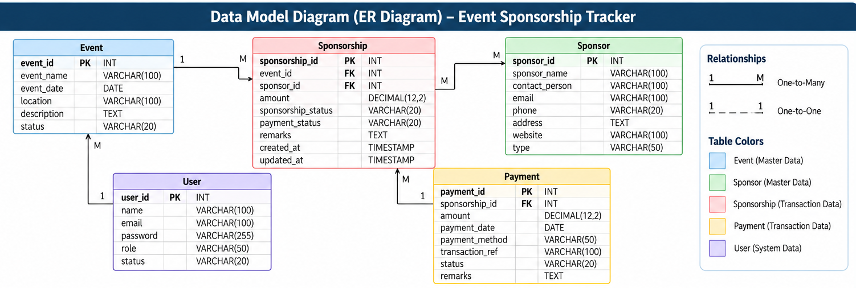
The MVP uses three core entities: Event, Sponsor and Sponsorship. An event can have multiple sponsorship records, and a sponsor can participate in multiple events through sponsorship records.

5.1 Entity Attributes
EVENT
Field | Type | Description
event_id | BIGINT | Primary key
event_name | VARCHAR | Event name
event_date | DATE | Event date
venue | VARCHAR | Event venue
description | VARCHAR | Event description

SPONSOR
Field | Type | Description
sponsor_id | BIGINT | Primary key
sponsor_name | VARCHAR | Sponsor name
contact_person | VARCHAR | Contact person
email | VARCHAR | Sponsor email
phone | VARCHAR | Sponsor phone

SPONSORSHIP
Field | Type | Description
sponsorship_id | BIGINT | Primary key
event_id | BIGINT | Foreign key to Event
sponsor_id | BIGINT | Foreign key to Sponsor
amount | DECIMAL | Sponsorship amount
sponsorship_status | VARCHAR | Proposed/Confirmed/Pending/Completed/Cancelled
payment_status | VARCHAR | Pending/Partial/Paid/Overdue
created_at | DATETIME | Creation timestamp
updated_at | DATETIME | Last update timestamp

6. API List
Method | Endpoint | Purpose
GET | /api/events | Get all events
GET | /api/events/{id} | Get an event by ID
POST | /api/events | Create an event
PUT | /api/events/{id} | Update an event
DELETE | /api/events/{id} | Delete an event
GET | /api/sponsors | Get all sponsors
GET | /api/sponsors/{id} | Get a sponsor by ID
POST | /api/sponsors | Create a sponsor
PUT | /api/sponsors/{id} | Update a sponsor
DELETE | /api/sponsors/{id} | Delete a sponsor
GET | /api/sponsorships | Get sponsorship records
GET | /api/sponsorships/{id} | Get sponsorship details
POST | /api/sponsorships | Create a sponsorship
PUT | /api/sponsorships/{id} | Update a sponsorship
GET | /api/sponsorships/status/{status} | Filter sponsorships by status
GET | /api/dashboard/summary | Get dashboard indicators
GET | /api/dashboard/exceptions | Get pending/overdue records
GET | /actuator/health | Check application health

7. Local Development Setup
Step | Setup Activity | Expected Result
1 | Install JDK 21 | Verify using java -version.
2 | Install Maven | Verify using mvn -version.
3 | Install MySQL | Create the project database.
4 | Create Spring Boot project | Use Java 21, Maven and required Spring dependencies.
5 | Configure database | Set MySQL connection properties in application configuration.
6 | Run the application | Start Spring Boot locally.
7 | Verify application | Open the local application URL in a browser.
8 | Run Maven build | Use mvn clean test and mvn package.
9 | Initialize Git | Create repository and commit the working skeleton.

7.1 Proposed Project Structure
event-sponsorship-tracker/
├── pom.xml
├── src/main/java/com/eventtracker/
│ ├── controller/
│ ├── service/
│ ├── repository/
│ ├── model/
│ └── EventSponsorshipTrackerApplication.java
├── src/main/resources/
│ ├── templates/
│ ├── static/
│ └── application.properties
└── src/test/java/

8. Selected Build and Deployment Approach
Maven is selected as the build tool because the project is implemented in Java and the later Jenkins and Selenium stages require a repeatable command-line build. The application will be packaged as a Spring Boot JAR and run using the embedded Tomcat server. Nginx will be used as a reverse proxy in the deployment setup. For later DevOps tasks, the application will be packaged into a Docker image and deployed as a container.

10. Task 3 Conclusion
Task 3 defines the technical foundation of the Containerized Event Sponsorship Tracker. The selected architecture, technology stack, data model and APIs provide a small but complete MVP that can be developed locally and subsequently integrated with GitHub, Maven, Jenkins, Selenium, Docker, Nginx and Ansible during the remaining DevOps tasks.

